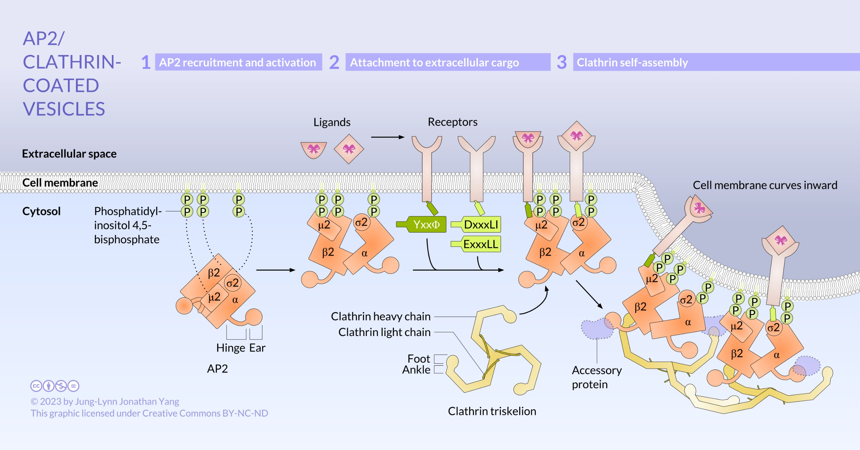

The assembly of clathrin-coated vesicles at the cell membrane is mediated by the adaptor complex AP2, which consists of four subunits: β2, α, μ2, and σ2. Patches of the cell membrane enriched with phosphatidylinositol 4,5-bisphosphate recruit AP2 from the cytosol to the cell membrane. AP2 is in a closed conformation that is opened into the active conformation by interacting cooperatively with phosphatidylinositol 4,5-bisphosphate and receptors. There are phosphatidylinositol 4,5-bisphosphate binding sites on β2, α, and μ2 subunits (dotted lines). The μ2 subunit binds to cargo that contain the sequence YxxΦ, while the σ2 subunit binds to the dileucine sequence DxxxLI or ExxxLL. The ankle domain of clathrin attaches to the β2 hinge of AP2. The foot domain of clathrin and the ear domains of β2 and α of AP2 bind accessory proteins. The continued assembly of clathrin on the membrane surface deforms the cell membrane into the cell. (Source: Jung-Lynn Jonathan Yang)

