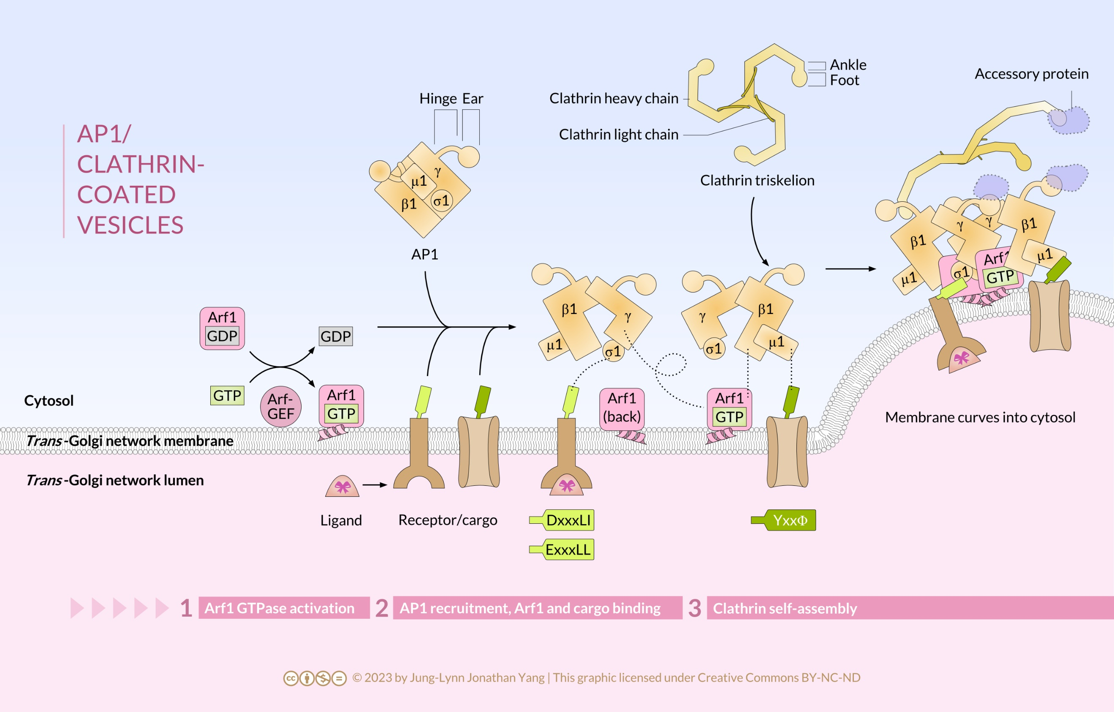

Clathrin-coated vesicles from the membrane of the trans-Golgi network traffic output from the Golgi apparatus to endosomes. The adaptor complex AP1, which consists of the subunits β1, γ, μ1, and σ1, mediate clathrin assembly. Activating AP1 is a cooperative mechanism among two copies of both AP1 and ARF1 and cargoes. The dotted lines show the regions of contact among AP1, ARF1, and cargoes. The Arf-GEF activates ARF1 by nucleotide exchange. The front side of ARF1 binds to the β1 subunit of one AP1, and the back side (looped dotted line) binds to the γ subunit of the other AP1. The second copy of ARF1 binds similarly as the first ARF1 but, for simplicity, is not shown in the diagram. The μ1 subunit binds to cargo that contain the sequence YxxΦ, while the σ1 subunit binds to the dileucine sequence DxxxLI or ExxxLL. Transmembrane cargo, such as the ion channel shown, contain sequences that bind to AP1. Receptors sequester soluble cargoes into clathrin-coated vesicles. The β1 hinge of AP1 binds to the clathrin ankle domain. The ear domains of β1 and γ, as well as the foot domain of clathrin, bind to accessory proteins. The continued assembly of clathrin on the membrane surface deforms the membrane into the cytosol. (Source: Jung-Lynn Jonathan Yang)

